# CASE STUDY 2: Soccer Analytics

# For Task 2.1,

This visualization ranks the top 5 goalkeepers based on the number of save attempts they made. The visual provides key details for each goalkeeper, allowing the manager to compare player attributes easily.

## Top 5 Goalkeepers:

1. Iván Cuéllar Sacristán (Spain): Made 204 save attempts, standing out with a height of 187 cm and a weight of 76 kg.
2. Norberto Murara Neto (Brazil): Ranked second with 202 save attempts. He is slightly taller at 190 cm and weighs 84 kg.
3. Fernando Pacheco Flores (Spain): Comes in third with 178 saves, standing 186 cm tall and weighing 81 kg.
4. Pau López Sabata (Spain): Made 161 saves, offering a height of 189 cm and weighing 77 kg.
5. Marc-André ter Stegen (Germany): Ranked fifth with 152 saves, standing at 187 cm with a weight of 85 kg.

## How I Made It:

First I fileted the role to Goal Keeper as we are finding the top5 goal keeper. Then I used Sub Event name and filtered it to Save Attempts, as we are looking for the actions taken by the Goal Keeper. Then I created 2 calculated fields one where I combined the first, middle and last name to make it a full name. Then I created the calculated field to rank and show the top 5 GKP. As per the requirements the height, weight and birth area are dragged to Tooltip and Label buttons. To fully satisfy the requirements.

This visualization gives a quick snapshot of the top-performing goalkeepers and provides easy access to key attributes such as height, weight, and nationality through tooltips. The manager can hover over each player to gain more context on the player’s physical profile, helping in making more informed decisions when selecting a new goalkeeper.

# For Task 2.2,

The visualization compares the game performance of Lionel Messi and Cristiano Ronaldo based on specific sub-events such as shots, passes, and free kicks.

## Game Performance:

* Shots: Lionel Messi leads with 1,886 shots, significantly more than Cristiano Ronaldo, who has 730 shots.
* Passes: Simple Passes: Messi again surpasses Ronaldo with 740 simple passes compared to Ronaldo’s 856.
* Smart Passes: Messi shows strength with 356 smart passes, while Ronaldo makes only 66.
* Free Kicks and High Passes: Messi makes 300 free kick shots compared to Ronaldo’s 110. Messi also leads in high passes, making 274 to Ronaldo’s 10.

## Physical Characteristics:

* Lionel Messi: Height: 170 cm Weight: 72 kg Dominant Foot: Left
* Cristiano Ronaldo: Height: 187 cm Weight: 83 kg Dominant Foot: Right

## How I Made It:

As we’ve already been given the Player Ids of the 2 GOATS. I dragged the player id to filter and just selected the two ids. I filtered out the important subevent names to evaluate and drag it to colour to make it more distinguishable.

## Summary:

Messi dominates in shots, free kicks, high passes, and smart passes, showcasing an exceptional ability in multiple areas of the game. Ronaldo, while making fewer passes and shots overall, is physically taller and heavier, which may offer different advantages on the field. This comparison will help the manager make an informed decision between the two based on t heir style of play, with Messi being more pass-focused and Ronaldo having physical advantages.

# For Task 2.3,

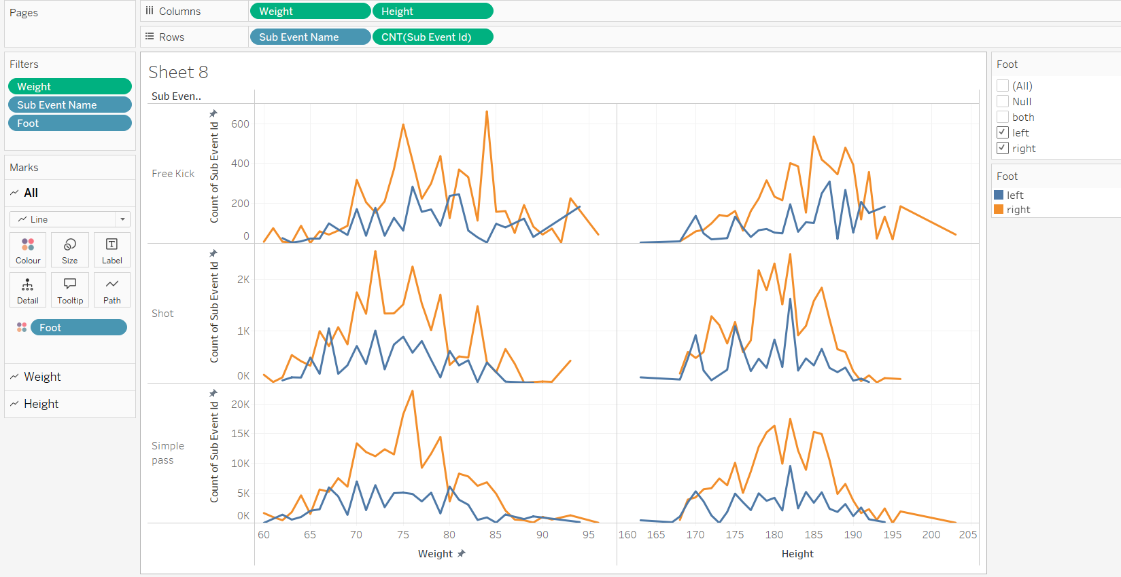

The visualizations compare the correlations between players' physical characteristics (weight, height, and foot preference) and their in-game performance (number of passes, shots, and free kicks).

## Correlation between Physical Characteristics and Game Performance:

### Free Kicks:

Players with a right foot (orange line) tend to make more free kicks in the middle weight range (around 75-85 kg) and height range (around 180-190 cm). There is a clear spike around 84 kg and 662 free kicks. Left-footed players (blue line) show fewer free kicks overall, peaking around the same weight and height ranges but with less consistency.

### Shots:

Right-footed players also dominate in shots, with the most activity seen in the 70-85 kg weight range. The shot count generally decreases for players above 85 kg. Left-footed players again show lower numbers of shots, but there is a small spike in the 180-190 cm height range.

### Simple Passes:

Simple passes seem to correlate strongly with both weight and height for right-footed players, especially in the weight range of 65-85 kg and height range of 170-190 cm. Left-footed players have fewer simple passes, but the trend is similar, indicating more passes from players within the same height and weight ranges.

### Key Insights:

Right-footed players show stronger performance across free kicks, shots, and simple passes, especially for those in the 70-85 kg weight range and 180-190 cm height range. Left-footed players exhibit lower overall performance but follow similar trends in terms of the weight and height ranges where their game performance is most effective.

This visualization will help the manager understand how physical attributes such as weight, height, and dominant foot impact player performance, especially for crucial game actions like free kicks, shots, and passes.

# Task 2.4:

Tableau Dashboard for Players Ranking and Match Period Comparison

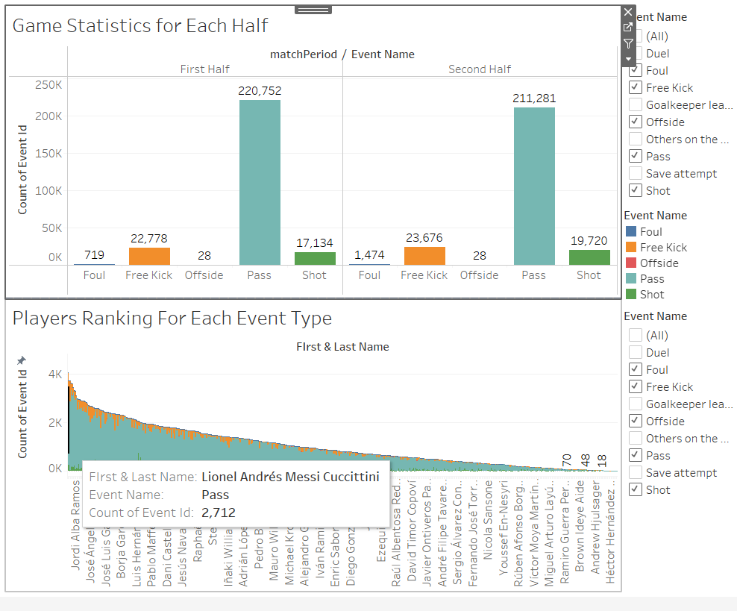

This visualisation addresses two primary objectives: ranking players based on specific event types and comparing game statistics between the first and second halves of matches.

### Ranking Players:

The first part of the dashboard focuses on ranking players based on selected event types, such as Pass, Shot, Free Kick, Foul, and Offside. The bar chart ranks players based on the count of these events For Example: Messi has been ranked number 1 because of the most number of passes made than any other player in the dataset. With each bar representing a player and its height representing the total number of the selected events they have performed.

### Match Period Comparison 1st & 2nd Half:

The second part of the dashboard allows for a comparison of game statistics between the first half (1H) and second half (2H) for the selected event type. This enables the manager to see how players or event outcomes vary between different match periods.

We can clearly see that in the first half of the match there were 220K passes made in first half. Whereas the number of passe slightly decreased in second half counting to 211K passes.

On the other hand we can see a significant increase in Number of Shots made in second half.17k in first half to 19k in second. Similarly freekicks and fouls seems to increase in the second half.

These insights suggest more aggressive gameplay and higher event activity in the second half of the match.

### Ranking Players Visualization:

### Bar Chart:

The players are ranked using a bar chart where the X-axis represents the players' names, and the Y-axis represents the count of events (e.g., Pass, Shot).

Colour: Different colours are applied to represent different event types (e.g., green for Pass, orange for Free Kick), helping the manager distinguish between multiple event categories.

Interactive Filters: Filters are applied so the user can dynamically switch between event types to view rankings for specific actions like shots or fouls. This provides flexibility for a customized view.

Annotations and Tooltips: The visualization includes hover-over tooltips that display additional player details like their total event count, adding a layer of interactivity and clarity.

### Match Period Comparison Visualization:

### Stacked Bar Chart:

A stacked bar chart is used to display game statistics for the first and second halves of the matches. This makes it easy to compare event counts (e.g., Pass, Free Kick) between 1H and 2H for each event type.

Colour: Each event type is differentiated by colour, helping the manager quickly see the distribution of events (Pass, Free Kick, etc.) across both halves.

Informative Labels and Titles: The chart is clearly titled with the event types and match periods to avoid confusion.

Informative labels for the count of events add more clarity to the comparison. This dashboard uses a combination of filters, informative titles, tooltips, and colour-coding to effectively communicate event-specific data allowing the manager to explore the data dynamically.